INTRODUCING SELF

Learning Objectives:
After following the learning process, the students are able to:
- Identify pronoun used in the dialogue of Introducing self.
- Write the dialogue using the correct pronoun

Activity 1: Fill in the blanks with the right pronouns.
- .... (Me/I) come to Yogyakarta every month.
- I am going to introduce…..(she/her) to my parents.
- .... (we/ours) plan to visit Thailand next year.
- Lolita told ….. (we/me) that she wanted to send the letter to her pen pal
- I am going to wash ……(my/me) hand
- Do you like ….. (you/your) meal today?
- .... (His/He) Spends the weekend playing guitar.
- .... (we/it) can climb Bromo Mountain together on July.
- …. (her/she) Hobby is playing guitar and listening to music.
- Rendy had many e-pals and he always keep in touch with….. (them/their)

Activity 2: Read the text bellow then answer the questions.
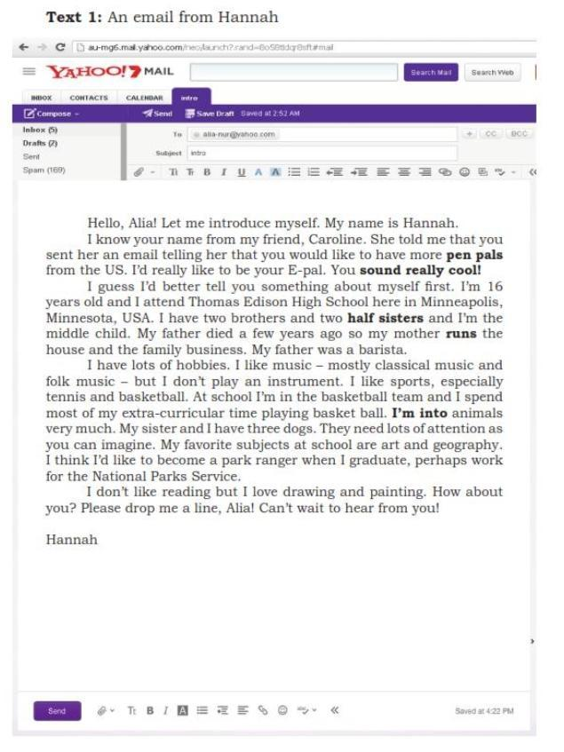
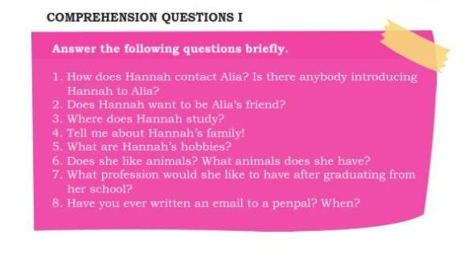

jawab:
1.Hanna contact Alia with an email
2.yes he wants to be his friend
3.Hanna study in Tomas Edison High School in Minneapolis Minnetosa USA
4.She have two brothers ,two half sisters ,and she have parent but ,she Father died
a few years ago so..,her mother runs the house and the family busniess.
5.Hanna hobbies is play the basketball and listening to music
6.Yes she have it three dogs
7.For the National parks service
8.no i never wrote it

Listen to the Audio then fill the blanks in the dialog.
Dialog 1
Yudi is at the cinema waiting for the film on air. He sees one seat vacant and approaches the boy sitting next to it.
Yudi : Excuse me. (1) ………..?excuse me can i sit next to you ?
Vito : Yes, sure.
Yudi : Thanks. By the way, I’m Yudi. May I know your name, please?
Vito : Hi, Yudi. I’m Vito.
Yudi : Nice to meet you, Vito.
Vito : Nice to meet you too, Yudi.
Yudi : Err … (2) …………….., Vito? where do you go to school Vito?
Vito : I study at SMAN 1.
Yudi : SMAN 1? (3) ……………..How about you
Vito : What a coincidence! (4)………………? I’m from Class XE. I also study at state high school 1
Yudi : I’m from Class XB. By the way, do you know Erlita?
Vito : Yes, I know her. She sits in front of me. (5) ……………..?btw where do you know him from?
Yudi : She is my neighbor.

Dialog 2
Erna and Entin are chatting while enjoying their drinks when Yudi passes by.
Erna : Hi, Yudi!
Yudi : Hi, Erna! Hello, Entin.
Entin : Hello, Yudi. Please join us here.
Yudi : (1) …………. By the way, is this seat vacant? (1)ok I’m coming
Erna : (2)………….. So, how’s everything with you, Yudi? (2)oh of course it's empty
Yudi : Everything is just fine. (3) …………….How abaut yours
Erna : We are, thanks.
Yudi : Well, may I know what you are talking about?
Erna : Sure. We’re talking about our friends from junior high school.
Yudi : (4) ……………..?ow ok
Entin : Yes. (5……………….. We’re happy we’re. you guys continue

